Operational Intelligence Dashboard in Excel Power Pivot
Dashboard Sample
Executive supply chain dashboard built with Power Pivot, DAX, PivotCharts, and slicers for operational KPI monitoring.

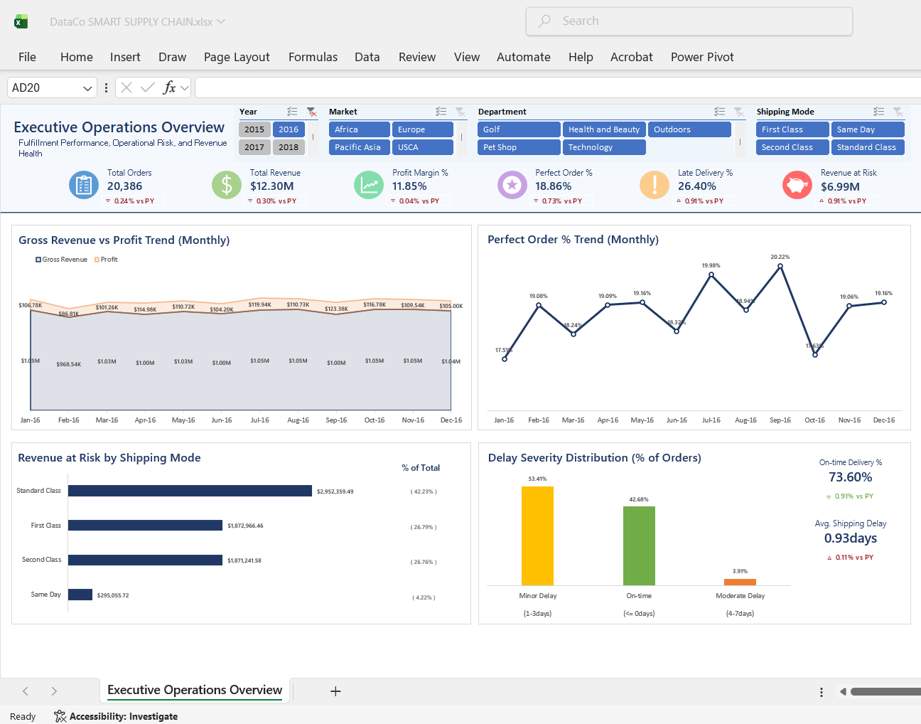

Sample DAX Measures & Data Model
Custom DAX KPI measures and normalized Power Pivot snowflake-schema model for scalable operational analytics.
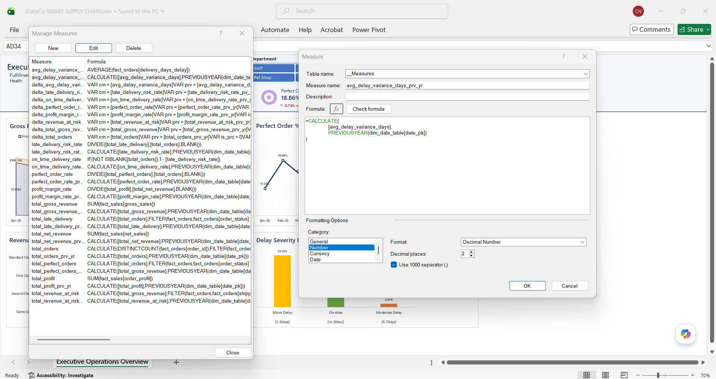

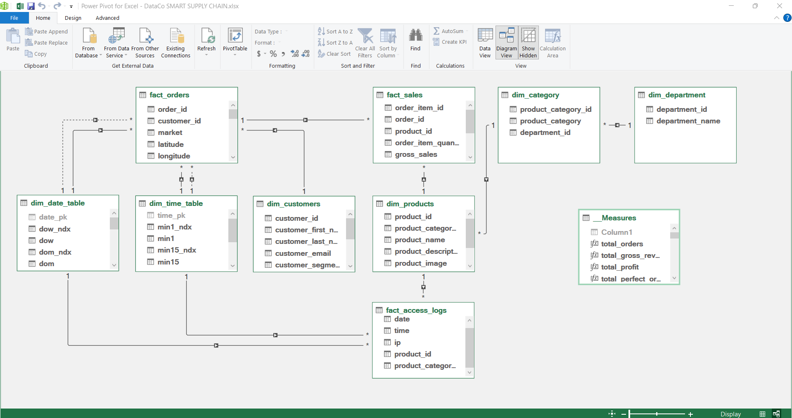

Queries & Connections
Power Query ETL layer managing fact and dimension tables for structured analytical reporting workflows.
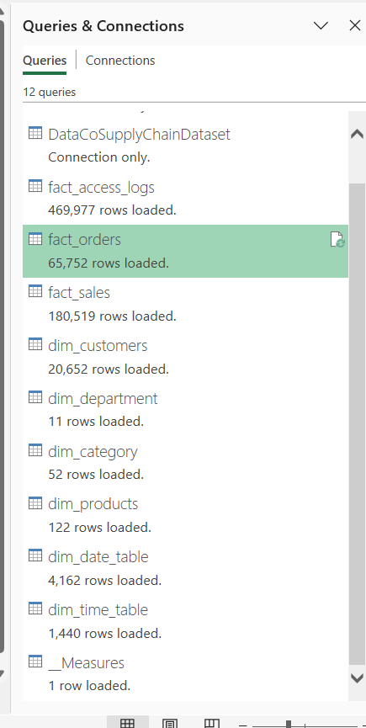

Power Query Sample
Sample Power Query transformation workflow showing cleansing, deduplication, and dimensional modeling preparation.
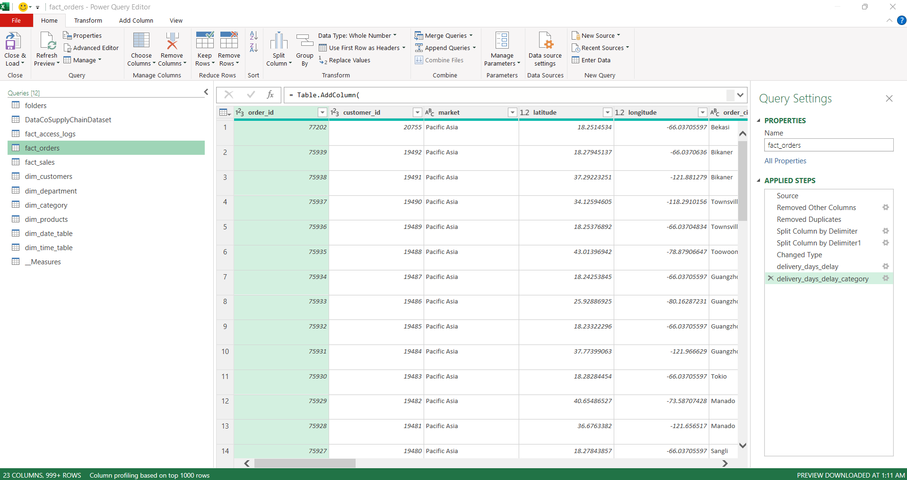

ETL & Data Modeling Approach
The ETL workflow was designed by analyzing the transactional grain and key relationships within the provided supply chain dataset. Fact and dimension tables were separated based on business process granularity, while reusable dimensions were created by grouping and deduplicating attribute columns using existing ID keys from the source dataset. The final model follows a normalized snowflake-schema structure optimized for Power Pivot analytics.

