Summary
This is Shield Joseph in United States.
I am a detail-oriented senior software engineer with expertise in full-stack development.
I build structured, scalable, high-performance and maintainable web applications using modern development practices.
I Specialize in creating responsive web applications using React.js and Node.js, and ensure high-quality code through rigorous reviews.
I create cross-platform applications with smooth performance and consistent UI/UX design by using Flutter.
I am ready to leverage expertise for impactful contributions in innovative technology project.
This profile showcases the results of the many projects I have actively contributed to and brought to success.

Skills/Tech Stack
Mobile: Flutter, Dart, React-Native, Android, Kotlin
Frontend: React.js, Next.js, Javascript/TypeScript, HTML/CSS,
Backend: Node.js, Express.js, Python, FastAPI, Flask, REST APIs, Firebase.
Database: MySQL, MongoDB, SQLite, PostgreQL
Tools: Git, Docker, CI/CD

Sofihub | HealthTech Monitoring Platform | Frontend & Mobile Developer
10/09/2018 ~ 04/11/2023
https://sofihub.com/
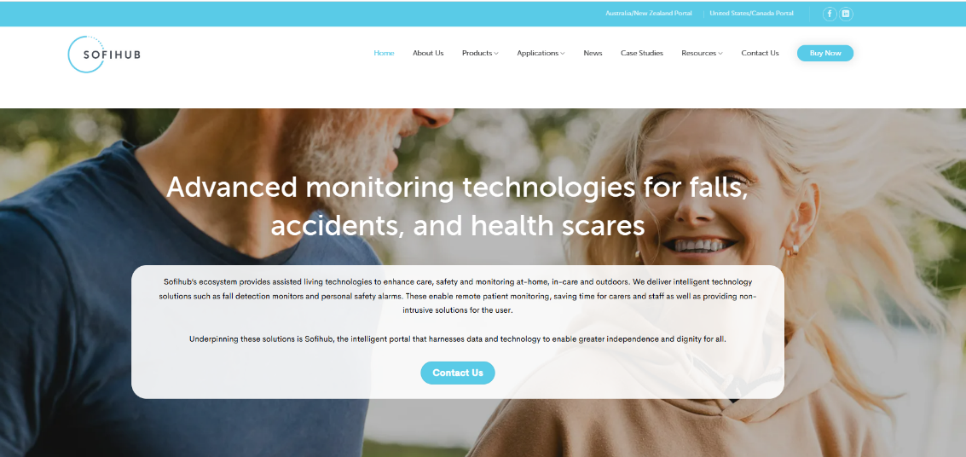
https://apps.apple.com/us/app/sofihub/id6444153627
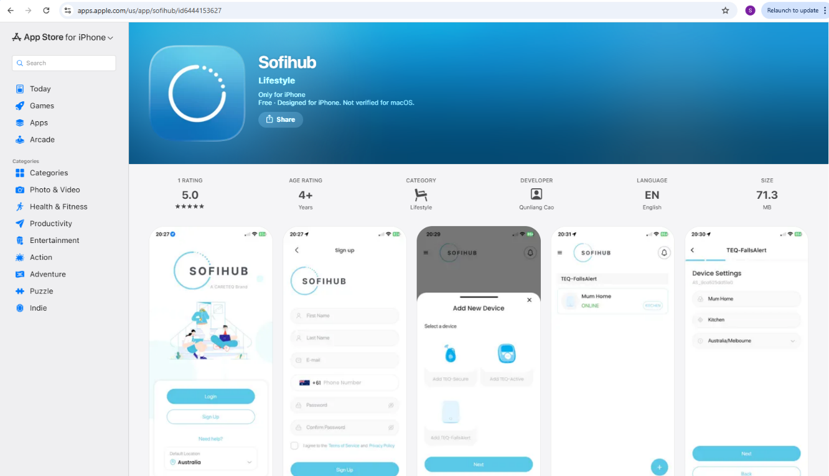
Contributed to the development of the Sofihub digital ecosystem, including the official website and cross-platform mobile application used for monitoring safety and health devices.
- Developed responsive and interactive web interfaces for the Sofihub website using modern frontend technologies, ensuring cross-browser compatibility and optimized user experience
- Built and maintained features for the Sofihub mobile application, enabling users to manage connected safety devices and receive real-time alerts
- Implemented UI components and application logic for device monitoring, notifications, and device configuration
- Collaborated with backend engineers and product designers to integrate APIs and deliver a scalable and maintainable application architecture
- Focused on performance optimization, clean component architecture, and user-friendly design across both web and mobile platforms
- Technologies: React.js, JavaScript, REST APIs, Flutter, Git

SmartShanghai / Smash-Asia – City Guide & Lifestyle Platforms
06/09/2023 ~ 02/20/2026
Frontend & Backend Developer
https://smartshanghai.com/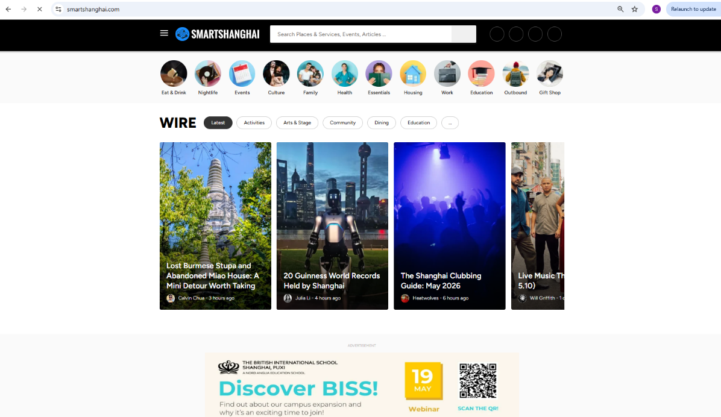
https://www.smash-asia.com/
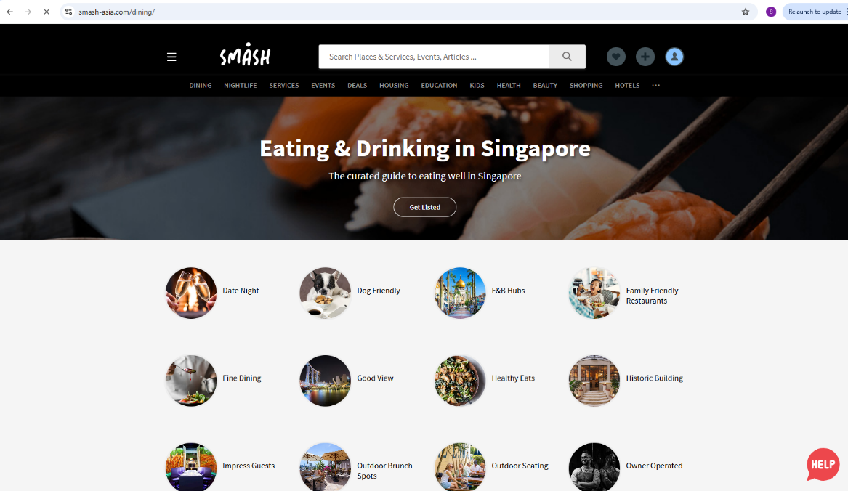
https://play.google.com/store/apps/details?id=com.smartshanghaiapp.smartshanghaicompany.smartshanghai&hl=en_US
https://apps.apple.com/us/app/smartshanghai/id353096339
https://play.google.com/store/apps/details?id=com.smashasiacompany.smashasia&hl=en_US

Worked on web and mobile applications for SmartShanghai (Shanghai) and Smash-Asia (Singapore), which are sister companies. These platforms provide city guides, event listings, and lifestyle information for international communities.
- Developed responsive user interfaces using React.js and Node.js for dynamic web applications of the SamrtShanghai website, improving user experience and performance
- Designed and implemented state management solutions with Redux to ensure efficient and scalable data flow in different parts of a system
- Integrated search functionality, caching and recommendation systems to improve performance and user experience when browsing large amounts of content in both websites
- Added an admin dashboard that allows editors to create, update, and publish content efficiently by creating effective workarounds and debugging code
- Improved their skills in optimizing performance, strengthening security and debugging production issues to keep systems stable and reliable for the Smash-Asia web application
- Technologies: React.js (Next.js), Node.js, JavaScript, Redux, Flutter, Git

