🧺 Sample Workflow: Laundry Pick-Up Confirmation + Reminder
🔹 Step 1: Go to the Workflow Builder
- Navigate to Automation → Workflows in your GHL dashboard.
- Click “+ Create Workflow” and choose “Start from Scratch” or use a template.
🔹 Step 2: Set the Trigger
This is what starts the workflow.
Trigger Example: Customer books a laundry pick-up via calendar.
- Choose “Appointment” as the trigger.
- Set filters: e.g., “Calendar = Laundry Pick-Up Calendar.”
🔹 Step 3: Add Actions
These are the steps that happen after the trigger.
Action 1: Send Confirmation SMS
- Message: “Hi [First Name], your laundry pick-up is confirmed for [Appointment Date & Time]. Thank you!”
Action 2: Wait 1 Day Before Appointment
- Use the “Wait” action: set it to 1 day before the scheduled time.
Action 3: Send Reminder SMS
- Message: “Reminder: We’re picking up your laundry tomorrow at [Appointment Time]. Please have it ready!”
Optional Action 4: Internal Notification
- Notify your team via email or SMS: “New pick-up scheduled for [Client Name] at [Time].”
🔹 Step 4: Test and Publish
- Use a test contact to run through the workflow.
- Check that messages send correctly and timing is accurate.
- Click “Publish” when ready.
🧠 Pro Tips for You
- Use Custom Fields: Personalize messages with client names, service types, etc.
- Tag Contacts: Add tags like “Pick-Up Scheduled” for easier tracking.
- Branch with Conditions: Use If/Else logic to send different messages based on service type (e.g., Wash & Fold vs. Dry Clean).
You can find a full walkthrough on GoHighLevel’s official support portal—it’s packed with visuals and examples.

🧺 1. Missed Appointment Follow-Up Workflow
Goal: Re-engage customers who missed their laundry pick-up or drop-off.
🔹 Trigger
- Appointment Status = No-Show
🔹 Actions
- Wait 1 Hour After Missed Appointment
- Send SMS
“Hi [First Name], we noticed you missed your laundry pick-up today. Would you like to reschedule?”
- Add Tag: Missed Appointment
- Notify Team: Internal alert to follow up manually if no response in 24 hours.
- Wait 24 Hours
- If No Response → Send Email
“We’re still holding your slot! Click here to reschedule or reply to this email.”
🔄 2. Customer Reactivation Workflow
Goal: Bring back inactive customers who haven’t booked in 30+ days.
🔹 Trigger
- Contact Tag = Inactive
(You can automate tagging based on last appointment date.)
🔹 Actions
- Send SMS
“We miss you! Book your next laundry service and enjoy 10% off. Offer valid this week only.”
- Wait 3 Days
- Send Email
“Still thinking about it? We’d love to help with your laundry needs. Here’s a quick booking link.”
- If Clicked → Add Tag: Reactivated
- If No Click → Wait 7 Days → Send Final Reminder SMS

⭐ 3. Review Request Workflow
Goal: Collect Google reviews after a successful service.
🔹 Trigger
- Appointment Status = Showed
or
- Tag Added = Completed Service
🔹 Actions
- Wait 1 Hour After Appointment
- Send SMS
“Thanks for choosing us, [First Name]! If you loved the service, would you mind leaving a quick review?”
Include Google review link.
- Send Email (Optional)
“Your feedback helps us grow! Here’s the link to leave a review.”
- Add Tag: Review Requested
- Track Responses: Use GHL’s reputation dashboard to monitor reviews.
📱 SMS Templates
1. Missed Appointment Follow-Up
Hi [First Name], we noticed you missed your laundry pick-up today. Need help rescheduling? Just reply here and we’ll get you sorted.
2. Customer Reactivation
Hi [First Name], we miss you! Book your next laundry service this week and enjoy 10% off. Tap here to schedule: [Booking Link]
3. Review Request
Thanks for choosing us, [First Name]! If you loved the service, we’d be so grateful for a quick review: [Google Review Link]
📧 Email Templates
1. Missed Appointment Follow-Up
Subject: Missed Your Laundry Pick-Up?
Body:
Hi [First Name],
We noticed you weren’t available for your scheduled laundry pick-up today. No worries—we’re happy to help you reschedule at your convenience.
Click below to book a new time or reply to this email if you need assistance.
👉 [Reschedule Link]
Warm regards,
[Your Business Name] Team
2. Customer Reactivation
Subject: We Miss You + A Little Thank You 🎁
Body:
Hi [First Name],
It’s been a while since your last laundry service, and we’d love to welcome you back!
As a thank-you, enjoy 10% off your next booking this week.
Click below to schedule your pick-up:
👉 [Booking Link]
We’re here to make laundry the easiest part of your week.
Cheers,
[Your Business Name] Team
3. Review Request
Subject: How Did We Do?
Body:
Hi [First Name],
Thanks again for trusting us with your laundry! We hope everything was fresh, folded, and fabulous.
If you have a moment, we’d love your feedback. Your review helps us grow and serve you better.
👉 [Google Review Link]
Appreciate you,
[Your Business Name] Team

Great question, Mailyn! Integrating your SMS and email templates into GoHighLevel workflows is super straightforward once you know where to click. Here's a step-by-step guide to help you plug in those templates and automate your laundry service communications like a pro 💼🧺.
🧩 Step-by-Step: Integrating SMS & Email Templates into Workflows
🔹 1. Create Your Templates First
Before adding them to a workflow, you need to save your messages as templates.
➤ For SMS:
- Go to Marketing → Templates → Add Template
- Choose Text Template
- Paste your SMS content (e.g., “Hi {{contact.first_name}}, your laundry pick-up is confirmed…”)
- Save and name it clearly (e.g., “Pick-Up Confirmation SMS”)
➤ For Email:
- Go to Marketing → Templates → Add Template
- Choose Email Template
- Paste your email content, format it, and preview
- Save and name it (e.g., “Review Request Email”)
🔹 2. Add Templates to a Workflow
Once your templates are saved, you can use them inside any workflow:
➤ Open Workflow Builder:
- Go to Automation → Workflows
- Create a new workflow or edit an existing one
➤ Add an Action:
- Click “+” to add a new action
- Choose “Send SMS” or “Send Email”
➤ Select Your Template:
- In the message field, click “Use Template”
- Choose the one you saved earlier
- You can still customize it with dynamic fields like {{contact.first_name}}
➤ Save & Test:
- Use a test contact to preview how the message looks
- Make sure the workflow triggers correctly
You can find a full walkthrough with visuals on GoHighLevel’s SMS action guide and a tutorial on creating and using templates.
💡 Pro Tips for You
- Use Tags Smartly: Add tags like Review Requested or Missed Appointment to track workflow progress.
- Test Before Launch: Always run a test with a dummy contact to catch formatting issues.
- Keep Templates Short & Friendly: Especially for SMS—brevity wins!

🧭 Workflow Map for Laundry Service Operations
Here’s a visual-style breakdown of how your workflows can be structured:
🟢 1. Booking & Confirmation
- Trigger: Appointment booked via calendar
- Actions:
- Send SMS confirmation
- Send internal notification to staff
- Tag contact as Booking Confirmed
🟡 2. Reminder Sequence
- Trigger: 1 day before appointment
- Actions:
- Send SMS reminder
- Optional: Send email reminder
- Tag contact as Reminder Sent
🔴 3. Missed Appointment Follow-Up
- Trigger: Appointment status = No-show
- Actions:
- Send SMS to reschedule
- Wait 24 hours → Send email
- Tag contact as Missed Appointment
🔵 4. Post-Service Review Request
- Trigger: Appointment status = Showed
- Actions:
- Wait 1 hour → Send SMS with review link
- Send follow-up email
- Tag contact as Review Requested
🟣 5. Reactivation Campaign
- Trigger: Contact inactive for 30+ days
- Actions:
- Send SMS with promo
- Wait 3 days → Send email
- Tag contact as Reactivated or Unresponsive

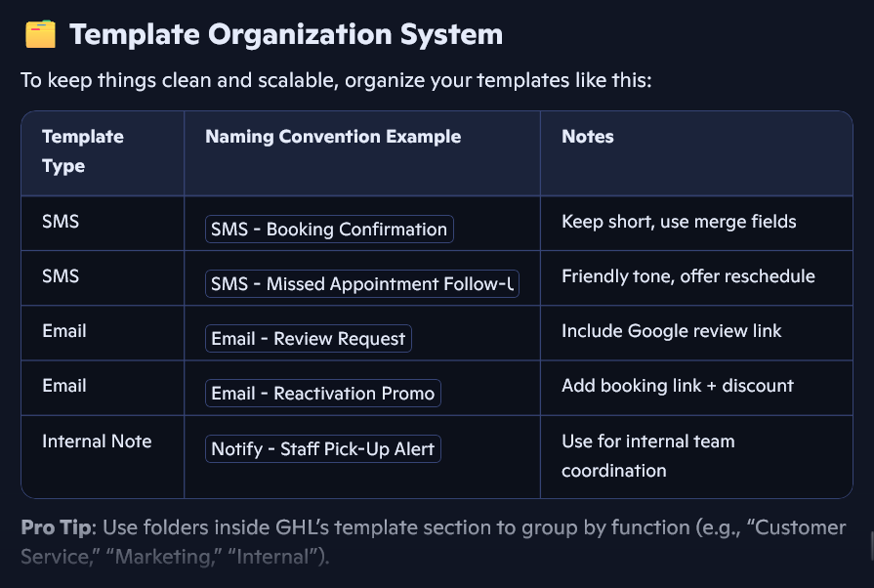

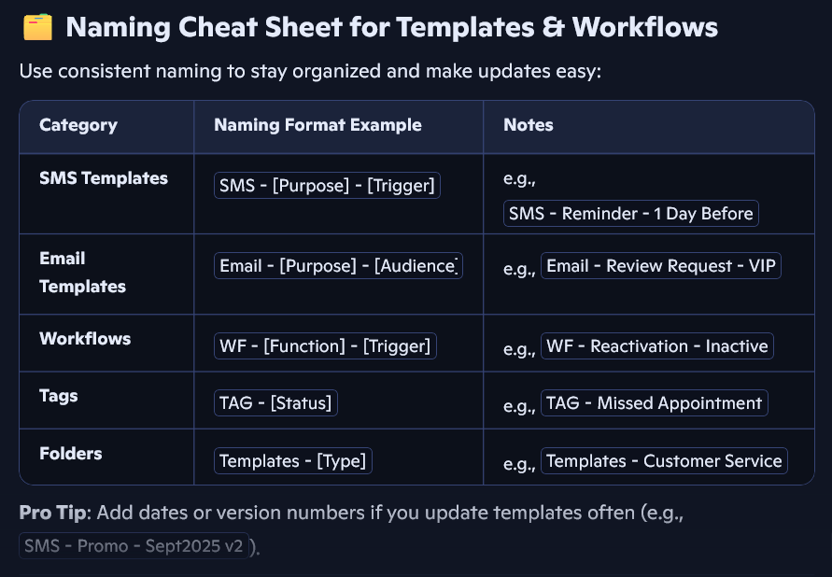

🗂️ Recommended Folder Structure in GoHighLevel
You can use nested folders to organize workflows and templates by function, client journey stage, or service type.
🔹 Top-Level Folders
- Workflows - Customer Journey
- Workflows - Internal Ops
- Templates - SMS
- Templates - Email
- Tags - Contact Status
🔸 Nested Folders (Examples)
Under Workflows - Customer Journey:
- Booking & Confirmation
- Reminders & No-Shows
- Post-Service Follow-Up
- Reactivation Campaigns
Under Workflows - Internal Ops:
- Staff Notifications
- Inventory Alerts
- Payroll & Finance Automation
Under Templates - SMS:
- Booking Confirmations
- Reminders
- Promos & Reactivation
- Review Requests
Under Templates - Email:
- Welcome Emails
- Follow-Ups
- Promotions
- Feedback & Reviews
🏷️ Tag System for Contact Management
Tags help you track customer behavior, workflow progress, and segment your audience.
🔹 Status Tags
- TAG - New Lead
- TAG - Booking Confirmed
- TAG - Missed Appointment
- TAG - Completed Service
- TAG - Review Requested
- TAG - Reactivated
🔹 Behavior Tags
- TAG - VIP Customer
- TAG - Frequent Booker
- TAG - Promo Responded
- TAG - No Response
🔹 Internal Use Tags
- TAG - Needs Manual Follow-Up
- TAG - Staff Alert Sent
- TAG - Payment Pending
🧠 Pro Tips for Managing Folders & Tags
- Use consistent naming: Start every folder or tag with a category prefix (e.g., TAG -, WF -, SMS -) for easy sorting.
- Review weekly: Archive unused workflows and clean up tags to avoid clutter.
- Document your system: Keep a simple SOP that explains what each folder and tag is for—especially helpful if you onboard team members.
You can explore GoHighLevel’s guide to nested folders for more tips on structuring your workspace.

📘 SOP: Weekly Workflow & Automation Management
This SOP outlines your weekly routine for managing GoHighLevel workflows, templates, and contact engagement.
🔹 Purpose
To ensure all automations are running smoothly, templates are up-to-date, and customer interactions are timely and professional.
🔹 Tools Needed
- GoHighLevel dashboard access
- Calendar (Google Calendar or similar)
- SOP checklist (this doc!)
- Access to SMS/email templates and contact tags
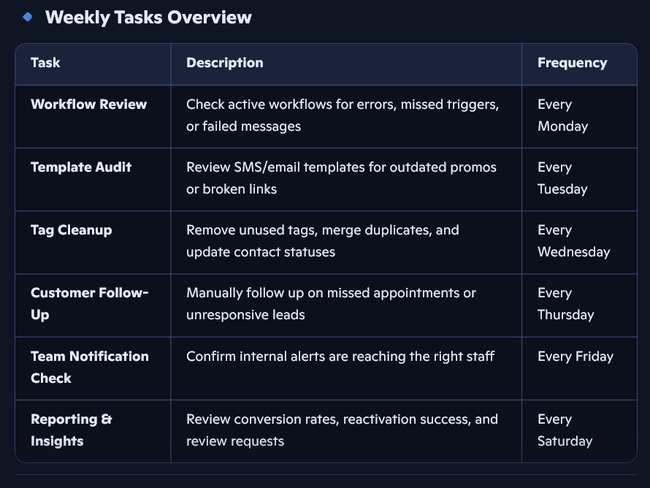

🏷️ Tag Glossary for Laundry Service CRM
Use this glossary to apply consistent tags across workflows and contact records.
🔹 Contact Status Tags
- TAG - New Lead: Contact has inquired but not booked
- TAG - Booking Confirmed: Appointment scheduled
- TAG - Missed Appointment: No-show or cancellation
- TAG - Completed Service: Service successfully delivered
- TAG - Review Requested: Review link sent
- TAG - Reactivated: Previously inactive, now rebooked
🔹 Customer Behavior Tags
- TAG - VIP Customer: Frequent or high-value client
- TAG - Promo Responded: Engaged with a discount or offer
- TAG - No Response: Ignored follow-ups or reminders
🔹 Internal Tags
- TAG - Needs Manual Follow-Up: Flag for personal outreach
- TAG - Staff Alert Sent: Notification sent to team
- TAG - Payment Pending: Awaiting invoice settlement
✨ Bonus Tip: SOP Template for New Workflow Setup
Title: “Laundry Pick-Up Reminder Workflow Setup”
Steps:
- Go to Automation → Workflows → Create New
- Set trigger: Appointment booked in “Laundry Pick-Up” calendar
- Add actions:
  - Send SMS confirmation
  - Wait 1 day before → Send SMS reminder
  - Add tag: Reminder Sent
- Test with dummy contact
- Publish and monitor

📘 SOP: Client Onboarding in GoHighLevel
This SOP ensures every new customer feels welcomed, informed, and ready to engage with your laundry service.
🔹 Objective
To automate and personalize the onboarding experience for new clients, from first contact to first service.
🔹 Workflow Steps
- Trigger: New contact added or first booking made
- Actions:
- Send welcome SMS:
“Hi {{contact.first_name}}, welcome to [Business Name]! We’re excited to handle your laundry needs. Here’s what to expect…”
- Send onboarding email with:
  - Service overview
  - Booking link
  - FAQs or contact info
- Assign tag: TAG - New Lead
- Add to pipeline stage: “Onboarding”
- Notify internal team: “New client added”
- Schedule follow-up reminder in 3 days
You can follow a full step-by-step guide on StartupWise’s onboarding workflow tutorial.
🧭 SOP: Staff Scheduling Management
This SOP helps you coordinate laundry staff shifts, pick-ups, and internal alerts using GoHighLevel.
🔹 Objective
To automate staff notifications and ensure coverage for all scheduled services.
🔹 Weekly Scheduling Routine
- Every Sunday:
  - Review upcoming appointments in GHL calendar
  - Assign staff to pick-ups/drop-offs based on location and time
  - Update shared Google Calendar or GHL calendar with shifts
- Daily Automation:
  - Trigger: Appointment booked
  - Actions:
  - Send internal SMS/email:
“New pick-up scheduled for {{contact.first_name}} at {{appointment.start_time}}. Assigned to [Staff Name].”
  - Tag contact: TAG - Staff Alert Sent
  - Add task: “Confirm staff availability”
- End-of-Day Review:
- Check for missed appointments
- Reassign or reschedule as needed
- Update tags: TAG - Completed Service or TAG - Missed Appointment
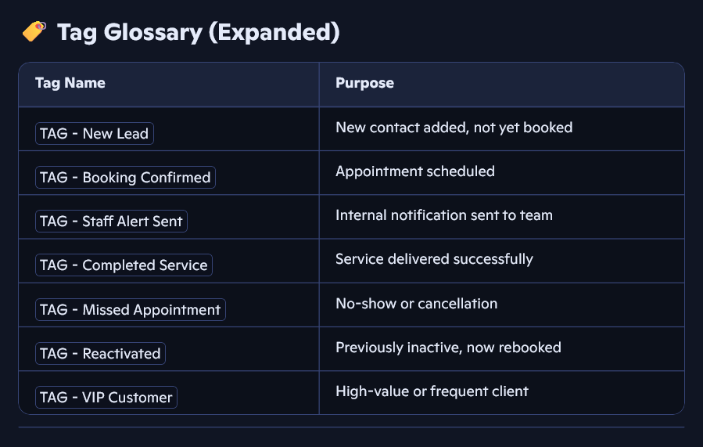

📊 Custom Dashboard Layout for Laundry Services
A GoHighLevel dashboard lets you monitor key metrics at a glance. Here's how to set one up:
🔹 How to Create It
You can follow GoHighLevel’s official dashboard setup guide. Here's a simplified version for your role:
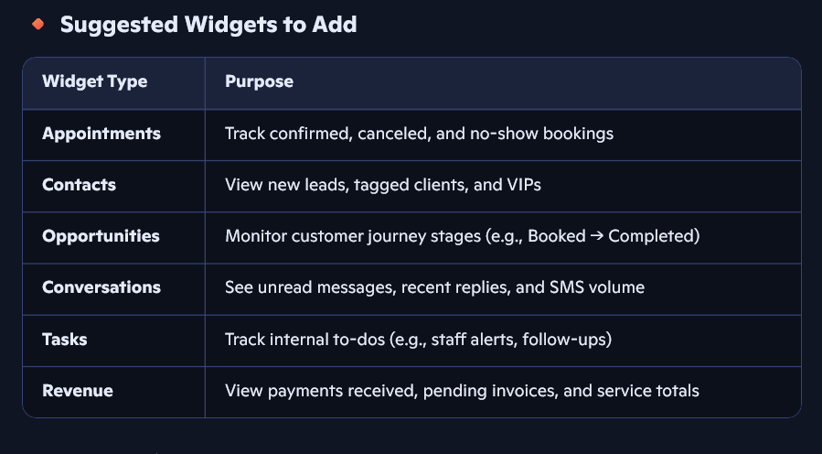
🔸 Layout Tips
- Group widgets by function: “Customer Flow,” “Team Coordination,” “Finance”
- Use color-coded tags to highlight urgent items
- Keep it clean—only show what you review weekly

📝 Client Intake Form for Laundry Services
This form helps you gather all the info you need to onboard a new customer smoothly.
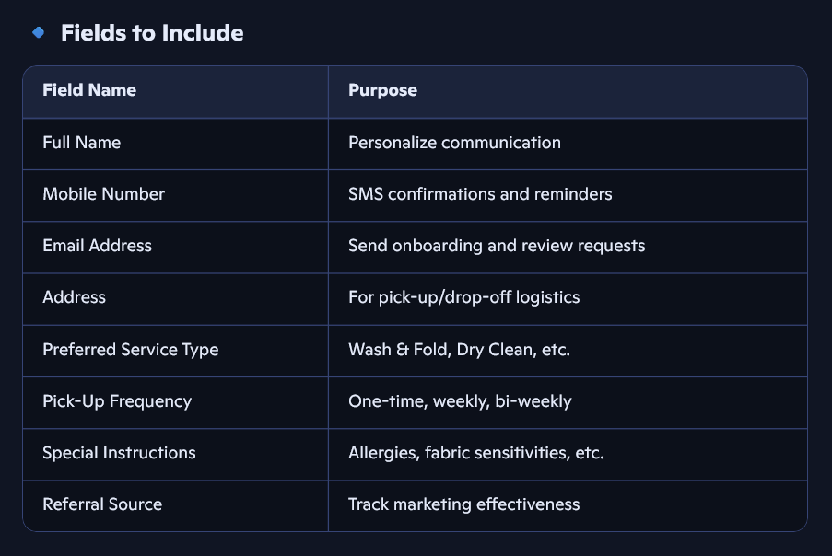

🎨 Branded Header for Client Intake Form
Here’s a clean, friendly header you can use at the top of your form:
🧺 Welcome to Crispy Clean Laundry Services!
We’re here to make laundry the easiest part of your week. Please fill out the form below so we can tailor our service to your needs. Your comfort, convenience, and satisfaction are our top priorities.

Tips for Styling in GoHighLevel:
- Use your brand colors for the header background or text.
- Add your logo above the header (PNG format works best).
- Keep font clean and readable—Sans Serif fonts like Open Sans or Lato work well.

💬 Welcome Message After Form Submission
Once a client submits the form, this message will appear:
🎉 Thank you, [First Name]!

Your request has been received. We’ll be in touch shortly to confirm your pick-up and walk you through the next steps. In the meantime, feel free to message us if you have any questions. We’re excited to serve you!

Optional Add-ons:
- Include a booking link: “Want to schedule right away? Click here to book your pick-up.”
- Add a WhatsApp or SMS contact button for instant support.

🧺 1. Branded Client Intake Form (GoHighLevel)
Header:
🧺 Welcome to Crispy Clean Laundry Services!
Your comfort, convenience, and satisfaction are our top priorities. Please fill out the form below so we can tailor our service to your needs.

Fields to Include:
- Full Name
- Mobile Number
- Email Address
- Address (for pick-up/drop-off)
- Preferred Service Type (Wash & Fold, Dry Clean, etc.)
- Pick-Up Frequency (One-time, Weekly, Bi-weekly)
- Special Instructions (Allergies, fabric sensitivities)
- Referral Source (Friend, Google, Facebook, etc.)

Submission Message:
🎉 Thank you, [First Name]!
Your request has been received. We’ll be in touch shortly to confirm your pick-up and walk you through the next steps. Feel free to message us anytime—we’re excited to serve you!

📧 2. Follow-Up Email Sequence
Email 1: Welcome & Service Overview
Subject: Welcome to [Business Name] Laundry Services!
Body:
Hi [First Name],
Thanks for signing up! We’re thrilled to take laundry off your to-do list. Here’s what you can expect:
- Easy scheduling
- Reliable pick-up and delivery
- Fresh, folded, and fabulous results
Click below to book your first service:
👉 [Booking Link]
Warm regards,
The [Business Name] Team
Email 2: Reminder to Book (if no action after 3 days)
Subject: Ready to schedule your laundry pick-up?
Body:
Hi [First Name],
Just checking in—have you had a chance to book your first laundry service? We’re ready when you are.
👉 [Booking Link]
Need help or have questions? Just reply to this email.
Cheers,
[Business Name] Team

Email 3: Review Request (after first completed service)
Subject: How did we do?
Body:
Hi [First Name],
Thanks again for choosing us! We hope everything was fresh, folded, and fabulous.
If you have a moment, we’d love your feedback:
👉 [Google Review Link]
Your review helps us grow and serve you better.
Appreciate you,
[Business Name] Team

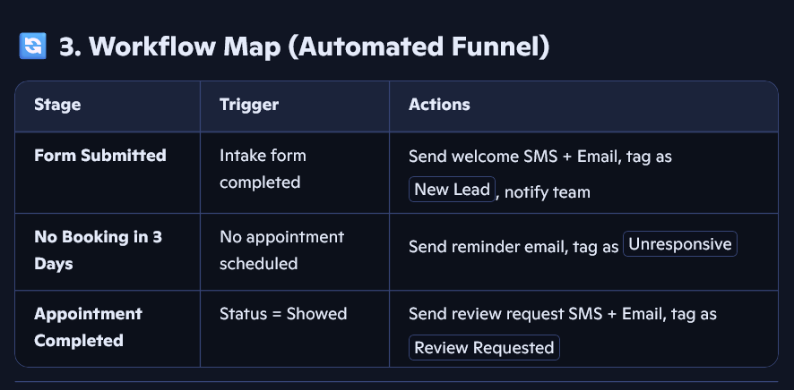

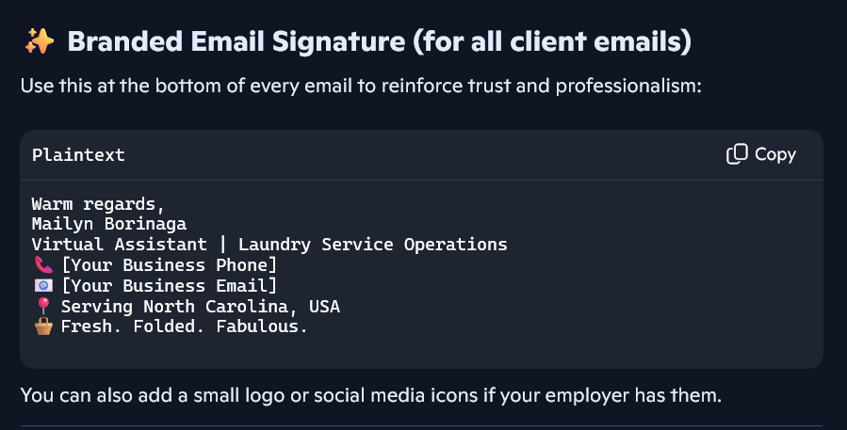

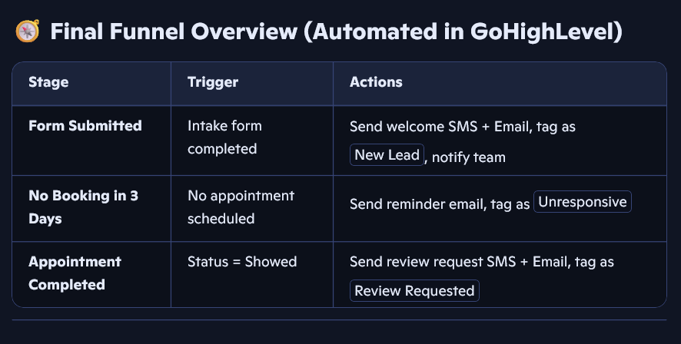

🧺 Daily SOP for Handling New Form Entries
Each morning, check for new submissions and follow this routine:
- Review new contacts in GHL → Contacts tab
- Confirm tags: Ensure New Lead is applied
- Check if booking was made
  - If yes → Tag as Booking Confirmed
  - If no → Leave in funnel for reminder email
- Notify team if pick-up is scheduled
- Log any special instructions for service team
- Update pipeline stage (e.g., “Onboarding” → “Scheduled”)
