Surya Pradipta
Full-Stack & Mobile Developer
Malang, Indonesia · (+62) 822-4896-9863 · Suryapradipta06@gmail.com

ABOUT
Computer Science student at Universitas Brawijaya with hands-on experience shipping production-ready mobile and web applications end-to-end. Comfortable working independently or in small teams under tight deadlines, with a track record of delivering complete products — from API design to frontend — in as little as one week. Skilled across Laravel, Flutter, React, Vue, Node.js, and cloud services.
TECHNICAL SKILLS
Languages | JavaScript, PHP, Python, Java, Dart, Kotlin, SQL, HTML/CSS
Frontend / Mobile | React, Next.js, Vue 3, Inertia.js, Tailwind CSS, Flutter, Chart.js
Backend & DB | Node.js, Laravel, REST API, MongoDB, SQLite, MySQL, Firebase, AWS
DevOps / Tools | Docker, Git, CI/CD, API Health Monitoring, Linux

PROJECTS
SyncUp — Team & Project Management Dashboard  Laravel · Vue 3 · Inertia.js · Tailwind  Co-developed a web-based project management system with kanban-style task tracking, priority labeling, and team collaboration. Handled project initiation, API design, error handling, and system architecture from the ground up.  [Laravel] [Real-time UI] [Collaborative] [Full CRUD] | 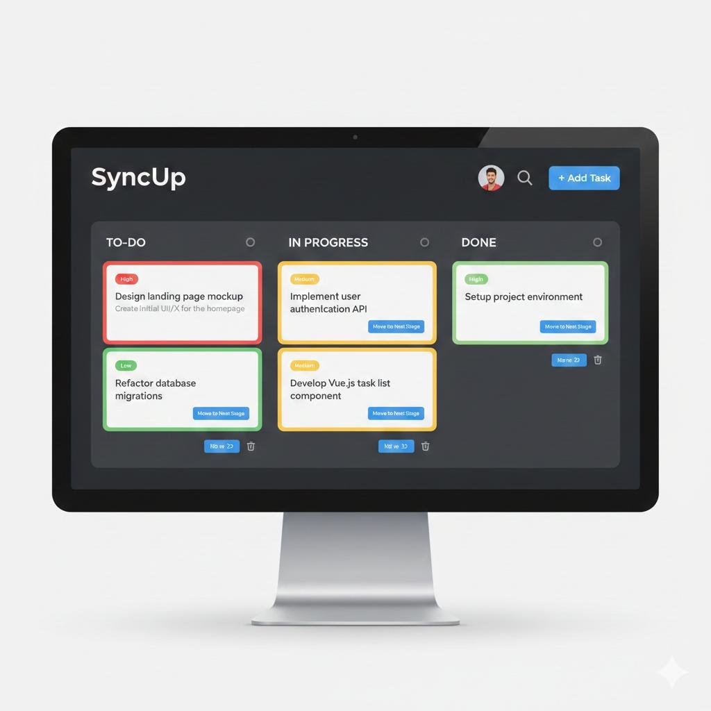

Sigma — Siaga Malang (Emergency Response App)  Kotlin · Android  Emergency response mobile app similar to an Amber Alert system. Real-time disaster reporting, emergency call integration, disaster guidance modules. Built in a 2-person team in 3 weeks; designed to assist hundreds of citizens across Malang.  [Real-time reporting] [Emergency calls] [2-person team] [3 weeks] | 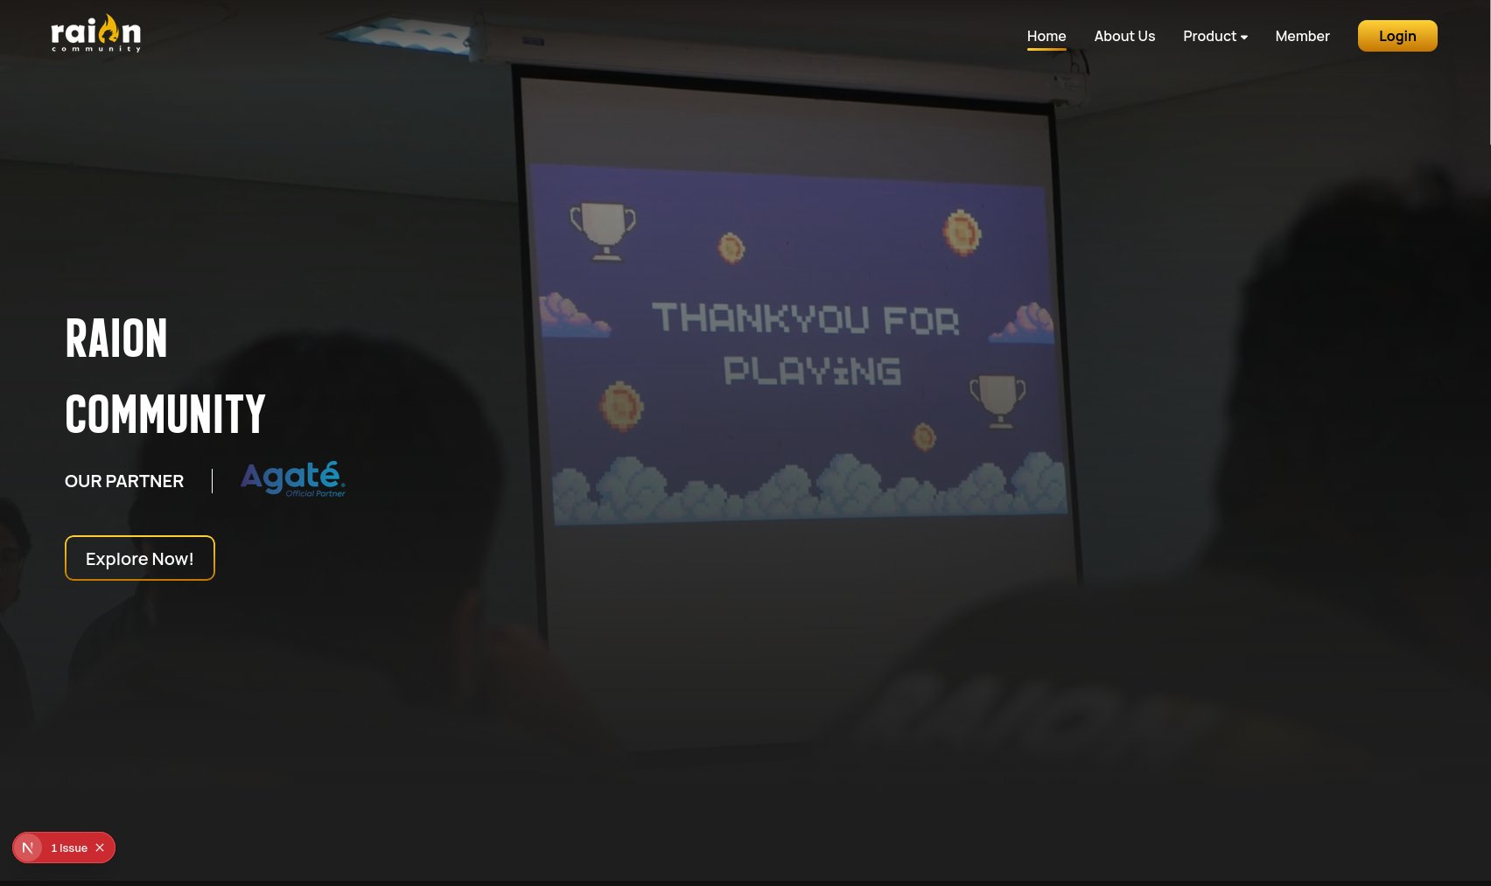

Vehicle Booking Management System  Laravel 13 · Vue 3 · Inertia.js · Tailwind · SQLite  Fleet management system for a nickel mining company. Features multi-level approval workflow (2+ levels), RBAC roles, Chart.js analytics dashboard, full activity logs, and Excel/CSV export. Delivered end-to-end in 1 week.  [RBAC] [Multi-level approval] [Analytics] [1 week] | 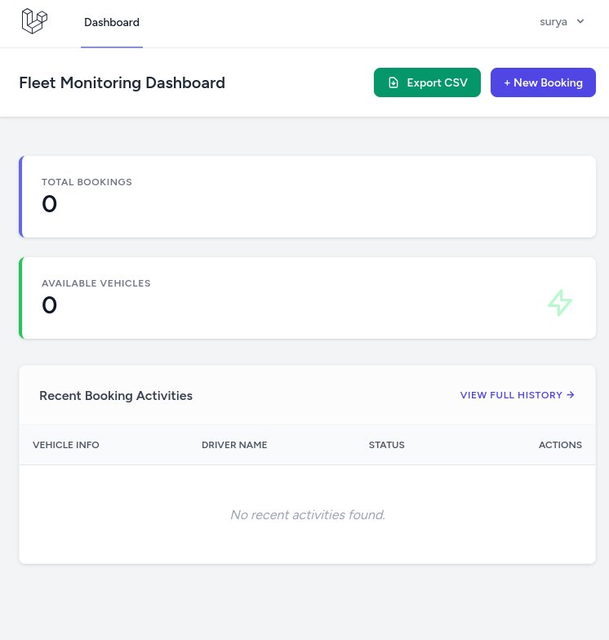

Jaganalar — Fake News Detection App  Flutter · Dart · Supabase · AI  Educational mobile app built solo in 1 week. AI-powered question generation, content evaluation, and gamified level progression to help students identify fake news. Scalable to 100+ concurrent students via Supabase.  [AI-powered] [Solo build] [1 week] [100+ concurrent users] | 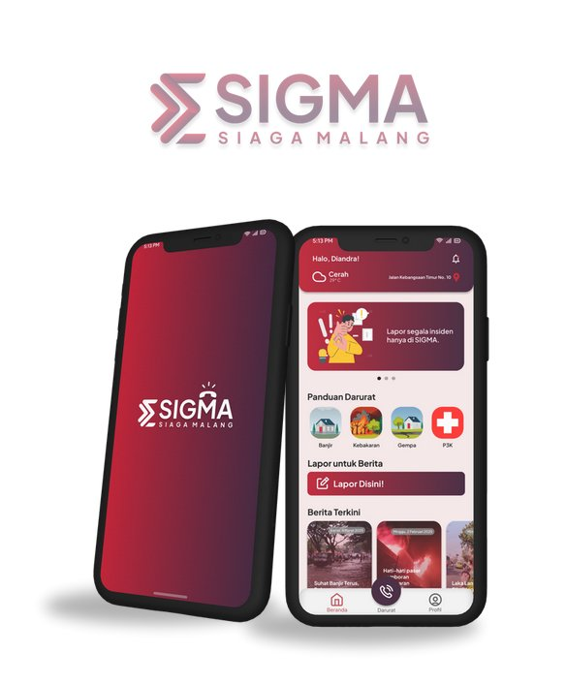

Phishing Email Detector  Python · HTML/CSS · AI/ML  Full-stack AI tool built independently in 3 days. Trained ML model, HTML/CSS submission interface, and full validation pipeline. Detects phishing vs. legitimate emails with over 98% accuracy.  [98% accuracy] [ML model] [3 days] [Solo build] | 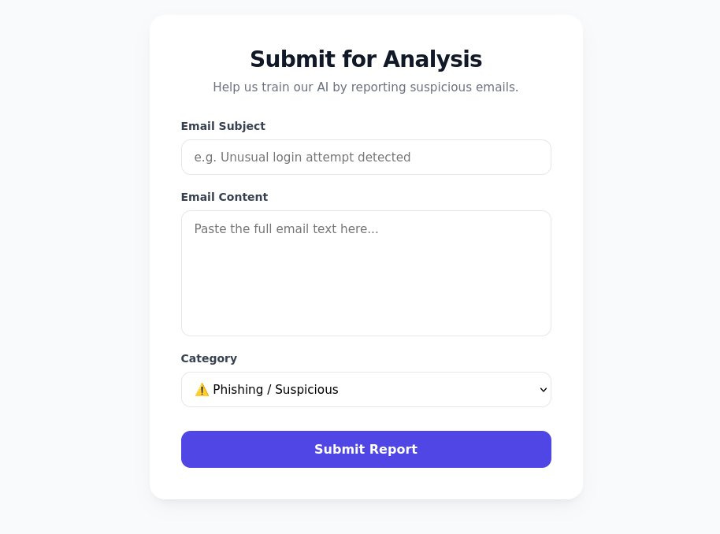

RAION Community Website  Internal Platform · Multiple cycles  Contributed to backend API initiation, error handling, database management, and microservices supporting core admin features. Platform serves thousands of visitors. Each feature delivered within 1–2 weeks.  [Microservices] [Thousands of visitors] [Production system] | 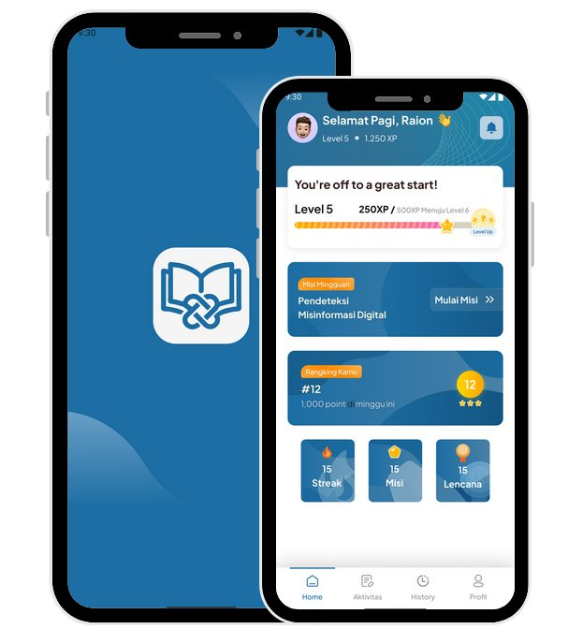

EXPERIENCE
Application Programmer | Feb 2024 – Jul 2025
RAION Community
- Shipped mobile and web products end-to-end across multiple cycles; each feature delivered within 1–2 weeks including frontend, backend, API design, and integration.
- Collaborated in small teams (2-person) and solo under tight deadlines, maintaining consistent delivery with minimal bugs.

Backend Engineer | Feb 2024 – Mar 2024
RAION Community
- Designed RESTful APIs and microservices for internal management systems; handled project initiation, API structure, and error handling from scratch.
- Migrated production database of hundreds of users in 2 weeks with minimal downtime, supporting a platform serving thousands of visitors.

Full-Stack Developer | Apr 2024
MoneyMate — Independent Project
- Designed and built base frontend (React) and contributed to mid & high fidelity Figma UI/UX designs for a fully custom budgeting web application.
- Developed backend API (Node.js) with complete technical documentation; assisted in product planning and system architecture for long-term scalability.

Full-Stack Developer | Mar 2026 – Present
SyncUp — Independent Project
- Co-developing a web-based team and project management dashboard system using Laravel.
- Handling project initiation, API design, error handling, and overall system structuring from the ground up.

EDUCATION
Bachelor of Computer Science — Universitas Brawijaya, Malang
Aug 2024 – Present
CERTIFICATIONS
- AI Literacy — IBM SkillsBuild
- Artificial Intelligence Fundamentals — IBM SkillsBuild
- Cloud Computing Fundamentals — IBM SkillsBuild

Suryapradipta06@gmail.com · (+62) 822-4896-9863 · Malang, Indonesia

